Forest of Mir
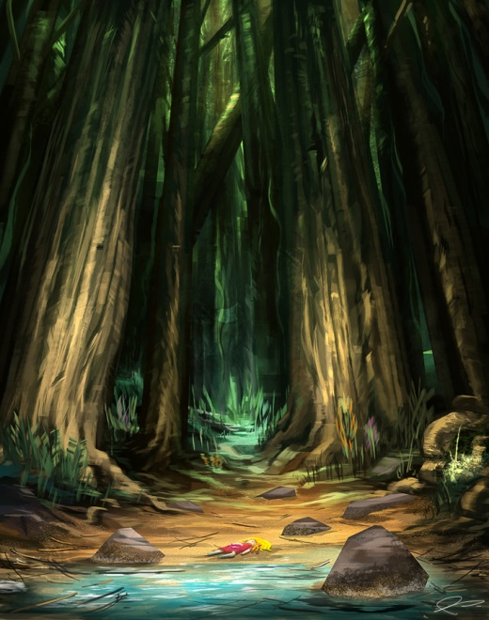
The Forest of Mir is another dangerous locale. While not as obviously deadly, the dangers of the Forest of Mir are more cunning and less apparent. The forest is hot, but there is plenty of water. Getting lost is a possibility, but there are a large number of trails and streams that can be followed until one’s bearings are regained. The primary danger to be found in the Forest of Mir is the monsters lurking within. The south leg of the forest has many different types of monsters, usually living alone or in small family groups. Ogres, goblins, and orcs have carved out small chunks of territory, but all are potential prey for the other monsters of the forest. Some human villages exist on the very edges of the forest, clearing a little timber and farming small plots of land, but the residents never go more than a mile or two into the forest. Brave hunting parties sometimes go deep in the forest in quest of a particular beast rumored to live within, and a few even come back.
The single biggest threat in the Forest of Mir, however, is the large population of elves in the western leg. Only the ignorant or the foolhardy enter this part of the forest; even the Pasha recently admitted that for all practical purposes, North Mir belongs to the Elves.
No one really knows just how many elves inhabit the Forest of Mir, but the best estimates give the total population at over 80,000. This total is divided into 8 to 10 tribes, each holding a small section of the forest for itself. The tribal leaders select one from among themselves to act as King of the Elves. The tribes are very independent, however, and meetings of all the tribes are very rare. They are usually called only when one of the many rivalries gets out of hand and erupts into war. The elves have substantial underground dwellings, storehouses, and passages dug out beneath the forest floor. Some say these tunnels connect with a vast underground network beneath all the Realms. The elves want very little to do with other surface-dwelling people (which is generally counted as a good thing by the people of Calimshan), and are more than happy to leave humans alone provided that they in turn are also left alone. Some brave explorers and traders have contacted the elves to acquire some of their weapons, handcrafts and other goods for sale to the outside world, but this does not happen often. There are three reasons: one, the elves never trade their best goods; two, the prices are outrageous; and three, not all the traders that enter the Forest of Mir come out.

